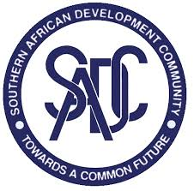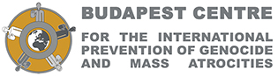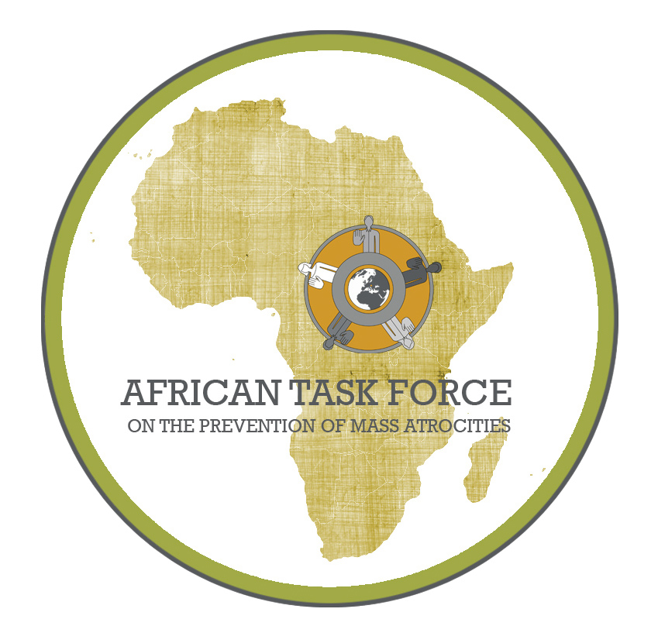

Joint Communique
on the workshop
organized by the Budapest Centre for the International Prevention of Genocide and Mass Atrocities in collaboration with the Secretariat of the Southern African Development Community

Following the Initiative of the Budapest Centre for the International Prevention of Genocide and Mass Atrocities to establish the African Task Force to map the capabilities of five regional organizations in Africa (AU, IGAD, ECOWAS, ICGLR and SADC) to prevent mass atrocities, a workshop was convened in Gaborone, Botswana on 27 November, 2015.

The Initiative of the Budapest Centre was launched in Addis Ababa on 18 March, 2015, with firm support expressed by the concerned organizations for the mission and objectives of the project, and their readiness to collaborate with it.

In the course of the workshop, the representatives of the the Budapest Centre and the African Task Force presented the Initiative and called the attention of the participants to the distinctions between prevention of violent conflict and prevention of mass atrocities, and the need to apply a specific „mass atrocity lens” during the conflict cycle to effectively detect and respond to risks relating to mass atrocities. The researchers of the African Task Force shared the findings of their research on the relevant capabilities of SADC with the representatives of the Organ on Politics, Defense and Security of SADC.

The participants of the workshop engaged in a constructive dialogue on the findings of the research and the current capabilities of SADC to prevent mass atrocities. There was a common understanding of the need to further sensitize the necessity to enhance the mass atrocity preventive approach during the daily activities, continue the exchange of views on the possibilities and ways to address the challenges in this field, and make further efforts to improve the capabilities of both the staff of the SADC Secretariat and SADC Member States in this domain.

The representatives of the Budapest Centre suggested the appointment of a focal point by the Organ on Politics, Defense and Security of SADC for facilitating future consultations on both the outstanding issues from the workshop and the feasible recommendations to be elaborated by the Budapest Centre as organic part of the Initiative.

